**LOGS MANAGEMENT IN LARAVEL**

**When logs**

We require logs to do debugging on our laravel project. We can see errors on live project.

**What is log?**

Log is a file produced by laravel that contain data many time we are setting. We can get into such condition where we require logs

Ok it will be producing in the storage folder then logs folder

**DEFAULT LOG**

// logs management in laravel

Route::get('/my-logs-management', function()

{

    Log::info('this is my testing log.');

    dd("done");

});

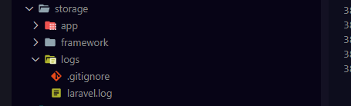



**Custom log**

Go to **config/logging.php** and find the channel path

Create the ‘custom’ array

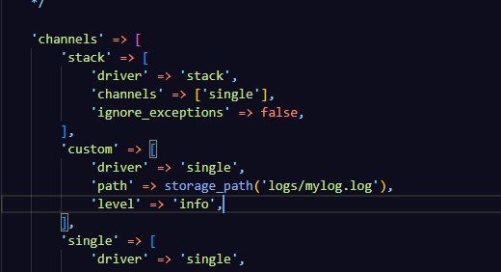

// logs management in laravel

Route::get('/my-logs', function()

{

    // Log::info('this is my testing log.');

    Log::channel('custom')->info('custom logs');

    dd("done");

});

So far I am failed to produced custom log file

**Activity log**